Lab -7- Part I

Tasks:
1.Write a function division() that accepts two arguments. The function should be able to catch an exception such as ZeroDivisionError, ValueError, or any unknown error you might come across when you are doing a division operation.
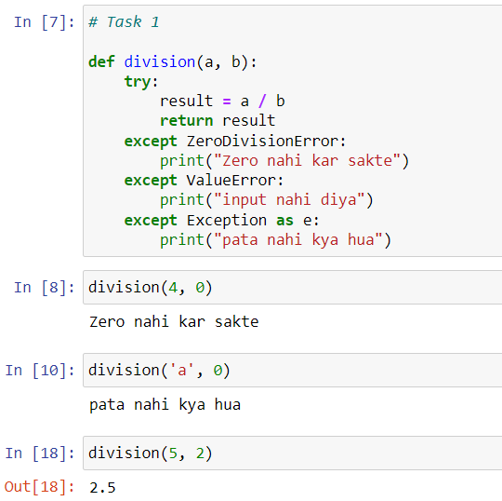
2. Write a Python program that calculates sum of square of n integers provided by the user. The program must raise an exception if user enters data of wrong data type.
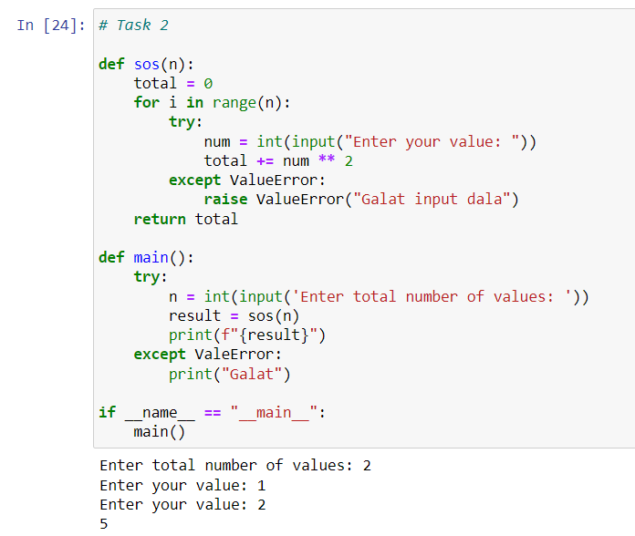
3. Write a Python program that prompts the user to input two numbers and raises a TypeError exception if the inputs are not numerical.
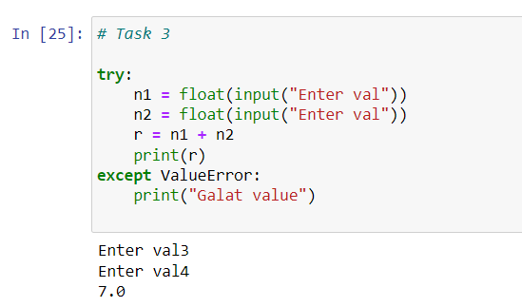
4. Write a Python program that executes an operation on a list and handles an IndexError exception if the index is out of range.
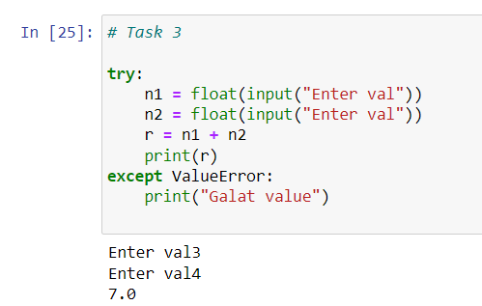
5. Write a python program to create a method that takes an integer as a parameter and throws an exception if the number is odd.
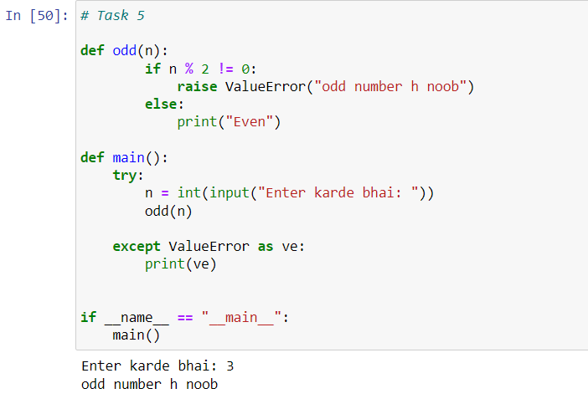
6. Write a Python program that calculates sum of square of n integers provided by the user. The program must raise an exception if user enters data of wrong data type.

